**HT7520**

**5.0MP 20X Automatic zoom HD IPC Module**

**systemM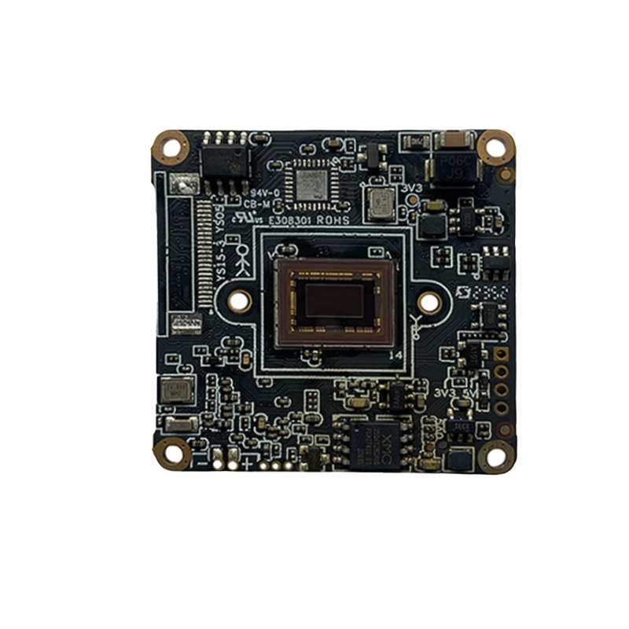odule**

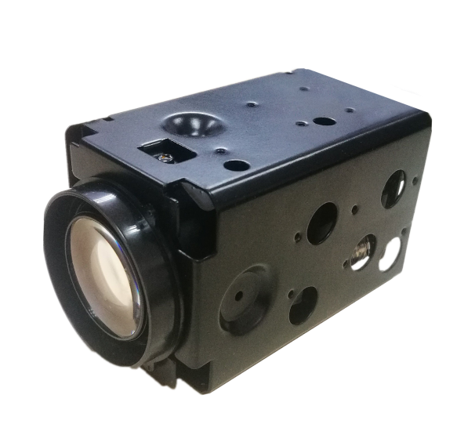

The HT7520 is a cost-effective 5MP surveillance network camera module designed for both indoor and outdoor use. It features a 1/2.8” Sony IMX335 STARVIS sensor and is powered by the GOKE GK7205V300 SoC, equipped with 1Gb of RAM. In terms of extended I/O capabilities, it supports dual light source illumination, as well as microphone and speaker connections, enabling two-way audio and additional interfaces.

For secondary development, the HT7520 includes two set UART interfaces and provides SDKs for Windows, Linux, and Android. It also supports the ONVIF standard protocol, along with OpenIPC and FPV firmware. This makes it highly convenient for secondary development and allows for quick integration into your projects.

**Key Features：**

● 1/2.8” 5MP Sony IMX335 STARVIS CMOS

● Maximum resolution up to 2592×1944@30fps

● 20X optical synchronous focusing, with clear images throughout the zoom process

● Support humanoid detection, motion detection

● Support the Tuya P2P on Android, IOS(Not default)

● Support two way audio, Built-in audio amplifier function

● Support ONVIF and HIK/XM protocol

● Support TCP/IP/HTTP/NTP/DHCP/SMTP/RTSP

● Open SDK(Linux,Windows), CGI, Support OPEN IPC development

**Technical Specifications:**

|  |  |
| --- | --- |
| **Image Sensor** | |
| Sensor | 1/2.8” 5MP Sony IMX335 STARVIS CMOS |
| Maximum Resolution | 2592x1944@30fps |
| Minimum Illumination | 0.02lux @F1.0(Color) / 0.01 lux@F1.0 (B/W) |
| **Shot** | |
| Focal length | 5.3-106mm，F1.7~3.6 |
| Viewing angle | 45°(nearfocus)~3°(farfocus) |
| **Camera** | |
| AGC | Auto/Manual |
| S/N Ratio | ≥45dB（AGC OFF） |
| Shutter Speed | 1/2 - 1/20 ,000s,Slow shutter support |
| Wide Dynamic Range | Digital WDR |
| Exposure Mode | Auto/ Manual/shutter mode |
| AWB | Yes |
| Day & Night | External control（IR Cut Filter） |
| Light Control | Support IR/White/dual light, three mode independent control |
| **Compression** |  |
| Video Compression | H.265/H.264 Main Profile /M-JPEG |
| Audio Compression | G711U,G711A,PCM |
| **Image Resolution** | |
| Main Stream | 2592x1944/1920x1080@30fps |
| Sub Stream | 640×480/480x360/352×288/176×144@30fps |
| **General Protocol** |  |
| Network Protocol | TCP/IP/HTTP/NTP/DHCP/SMTP/RTSP/P2P |
| ONVIF protocol | Yes |
| Compatibility | Support HIK/XM protocol |
| **P2P** |  |
| Support TUYA APP | Support for Tuya APP（Android, IOS） |
| **Function** |  |
| Autofocus / Zoom | Yes |
| Web Configuration | Yes |
| OSD | Yes |
| Motion Detection | Yes |
| Humanoid Detection | Yes |
| Reset | Support cable reset button(opticnal) |
| Amplifier | Built-in amplifier |
| **Interface** |  |
| Wired | 1ch 10/100 BaseT Ethernet,RJ45 interface |
| Audio | Microphone input/output |
| Alarm | 2 ports input, 2 ports output |
| UART | Support |
| USB | Support |
| TF Card | Optional and max. 512G (reserved extended SD slot) |
| **Other** |  |
| Power Supply | DC 12V |
| Size/Weight | 45x48x87mm /130g |
| Operation Temperature | -10°C~50°C |
| Working Humidity | ≤90%RH(non-condensing) |

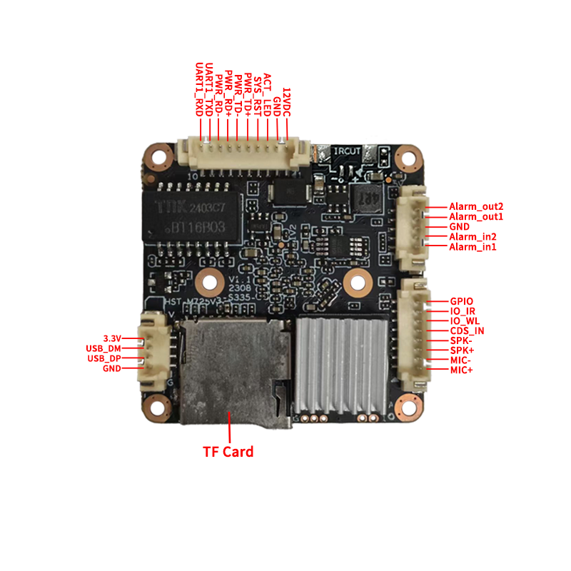

**Interface Pin Definition:**

|  |  |  |  |
| --- | --- | --- | --- |
| **Interface** | **pin** | **Pin name** | **Functional parameter** |
| **J1** | 1 | 12VDC | DC power input, voltage range 5V-13.8V |
| 2 | GND | GND |
| 3 | ACT_LED | Network indicator light interface |
| 4 | SYS_RST | Restore factory settings LOW valid |
| 5 | PWR_TD+ | Adaptive network interface, physically receiving/transmitting signals (differential +) |
| 6 | PWR_TD- | Adaptive network interface, physically receiving/transmitting signals (difference -) |
| 7 | PWR_RD+ | Adaptive network interface, physically receiving/transmitting signals (differential+) |
| 8 | PWR_RD- | Adaptive network interface, physically receiving/transmitting signals (difference -) |
| 9 | UART1_TXD | Serial communication, sending TX |
| 10 | UART1_RXD | UART1, receive RX |
| **J3** | 1 | Alarm_in1 | Alarm input 1 |
| 2 | Alarm_in2 | Alarm input 2 |
| 3 | GND | GND |
| 4 | Alarm_out1 | Alarm relay output 1 |
| 5 | Alarm_out2 | Alarm relay output 2 |
| **J4** | 1 | MIC+ | MIC+ |
| 2 | MIC- | MIC- |
| 3 | SPK+ | SPK+ |
| 4 | SPK- | SPK- |
| 5 | GDS_IN | Hard light sensitive infrared |
| 6 | IO_WL | Soft photosensitive white light |
| 7 | IO_IR | Soft photosensitive infrared |
| 8 | GPIO | 8 preview GPIO (PWM not supported) |
| **J5** | 1 | 3.3V | 3.3V power supply |
| 2 | USB_DM | data D- |
| 3 | USB_DP | data D+ |
| 4 | GND | GND |